**Documents to upload must be in PDF format.**

**GO TO :** <https://enligne.hec.ca/psp/GAPET/HEL/HRMS/?cmd=login&languageCd=ENG>

**Click on “Upload documents”**

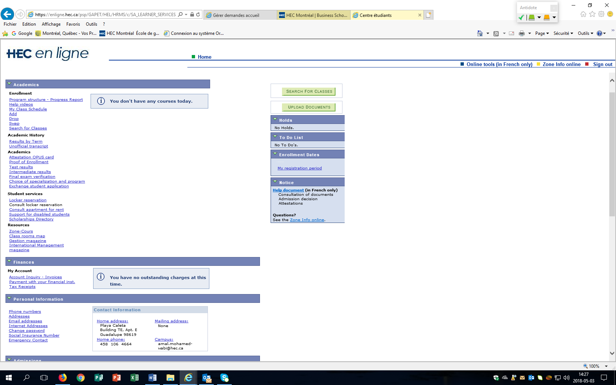

**DO NOT GO TO** section “Submit supporting documents”

**GO TO** section “Student file”

**Under Career,** choose Visiting Student.

**Under Attachment type**, choose Passport.

Click on **Add attachment.**

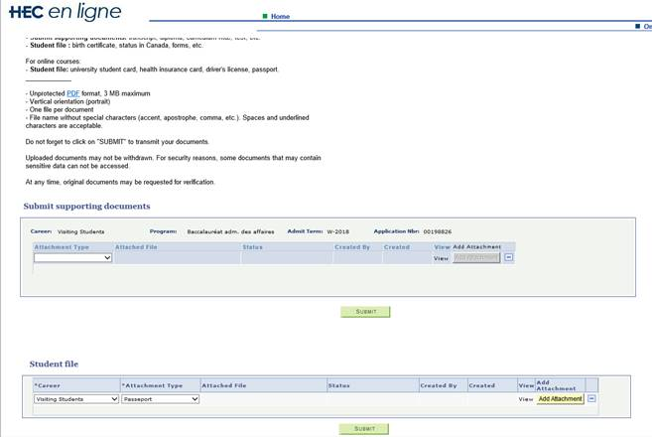

**Click on « Parcourir »** to locate the pdf document to upload

**Select the document**

**Then, click on “Upload”**

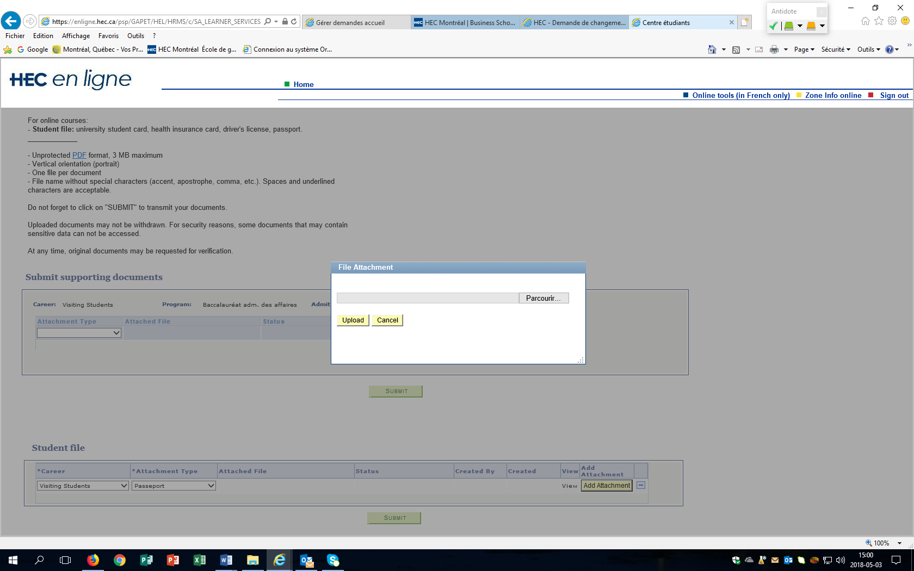

**Click on « Submit »**

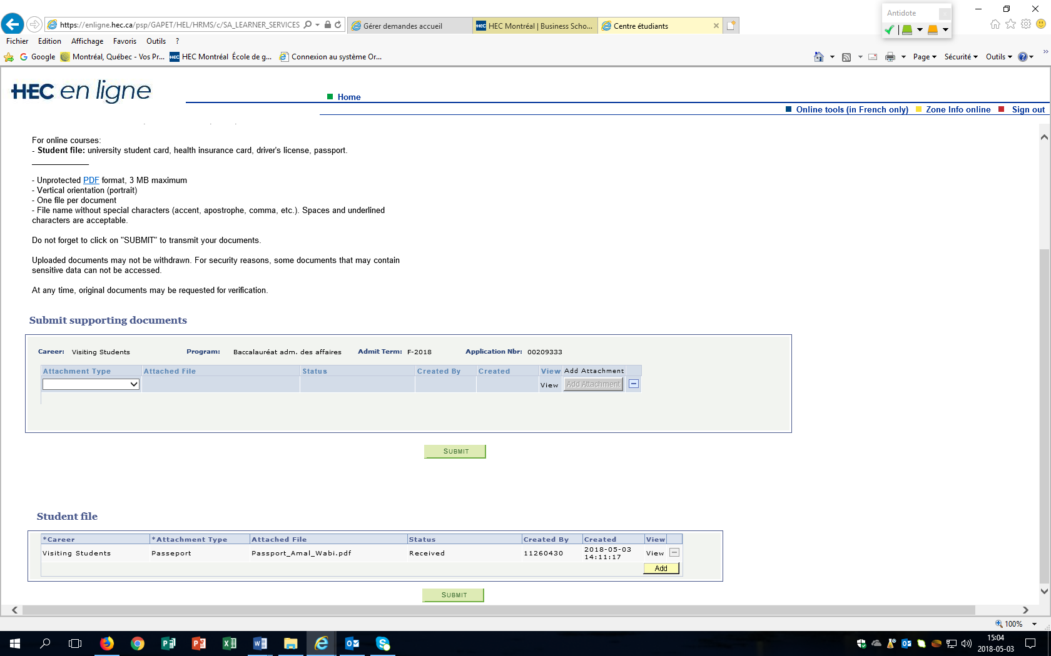

**The confirmation will appear as « Received »**